**TEAM NUMBER : 12**

**TEAM MEMBERS:** Sai Tejaswi Koppuravuri(30)

Lakshmana Kumar Mettu(35)

Anusha Reddy Palla (38)

Praneeth Thota(52)

1. **INTRODUCTION:**

**HEALTH INSPECTOR**

"Health Inspector" is a hybrid application with the fundamental plan to offer important rules to the client about their wellbeing. It basically focusses on finding the close-by specialists dependent on the clients area, giving the points of interest of the nourishment to be devoured dependent on the calories given by the client. In extra the client can ascertain his Body Mass Index (BMI) utilizing his weight and stature.

1. **PROJECT GOALS AND OBJECTIVE:** 
   1. **Motivation:**

Have you at any point thought of knowing the best specialists that you have close-by? It is safe to say that you are been contemplating the eating routine intend to pursue? Have you thought of consequently arranging an ideal eating routine for you? Indeed, we thought of it and built up an application called Health inspector which gives you an ideal day diet plan dependent on you selection of calories you require to devour.

* 1. **Significance and uniqueness:**

Presently there are numerous applications that screen the wellbeing conditions. In any case, in our application we are concentrating on the prerequisites required by the client with the end goal to know the close-by specialists dependent on their specialization. This application likewise gives the ideal eating routine arrangement to the day. The client can ascertain the BMI dependent on his height and weight.

* 1. **Objectives:**

The goal is to build up a hybrid application where in the client can login and improve his health encounter utilizing the highlights worked in. Since we are managing health it makes obvious that we ought to build up an engaging UI which catches the client eye. The application contains at first the client login exercises which ought to be anchored and we are likewise giving the client the eating regimen plan which to be precise and any wrong recommendations ought may deceive them. Indeed, even the client should impeccably happy with the administrations given by the application.

* 1. **System Features:**
* Ability to login the application safely with the client data
* To think about the client wellbeing conditions(if endorsed)
* Suggesting the client the best eating regimen plan in customary premise and not withstanding enabling the client to record his weight physically on standard premise.
* To ascertain client's BMI which is a valuable factor for a person.

**Github Issues:**

* Github issues were raised during the project increment.
* Different issues were assigned to different contributors of the project.

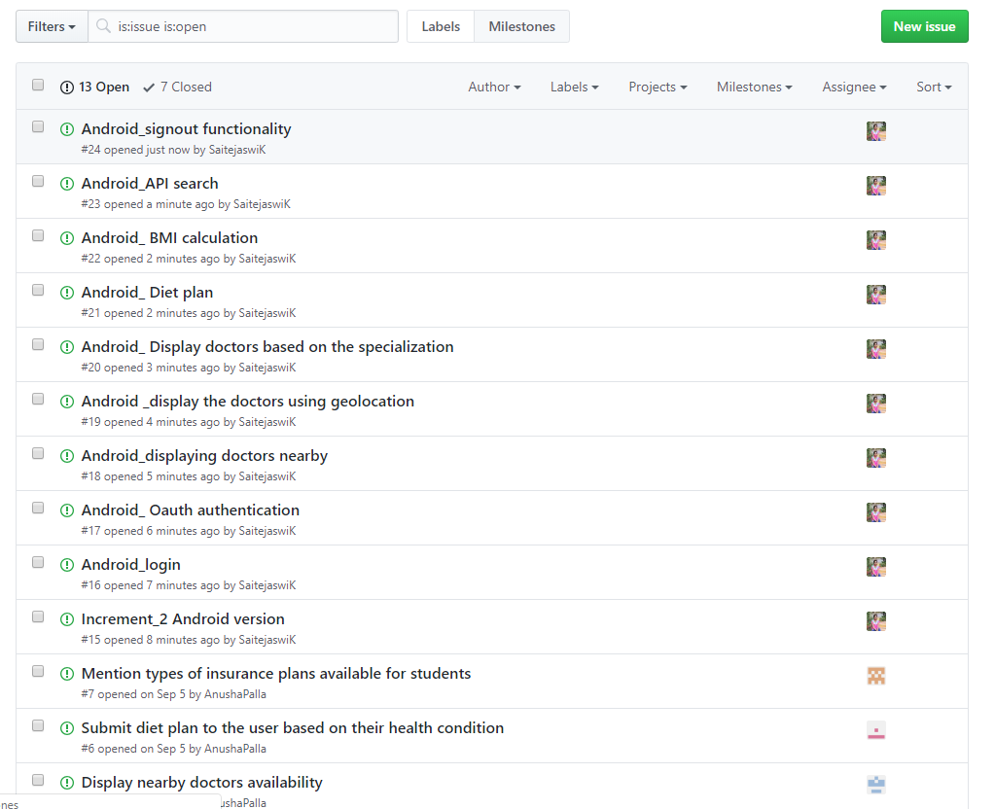

**Zenhub boarding:**

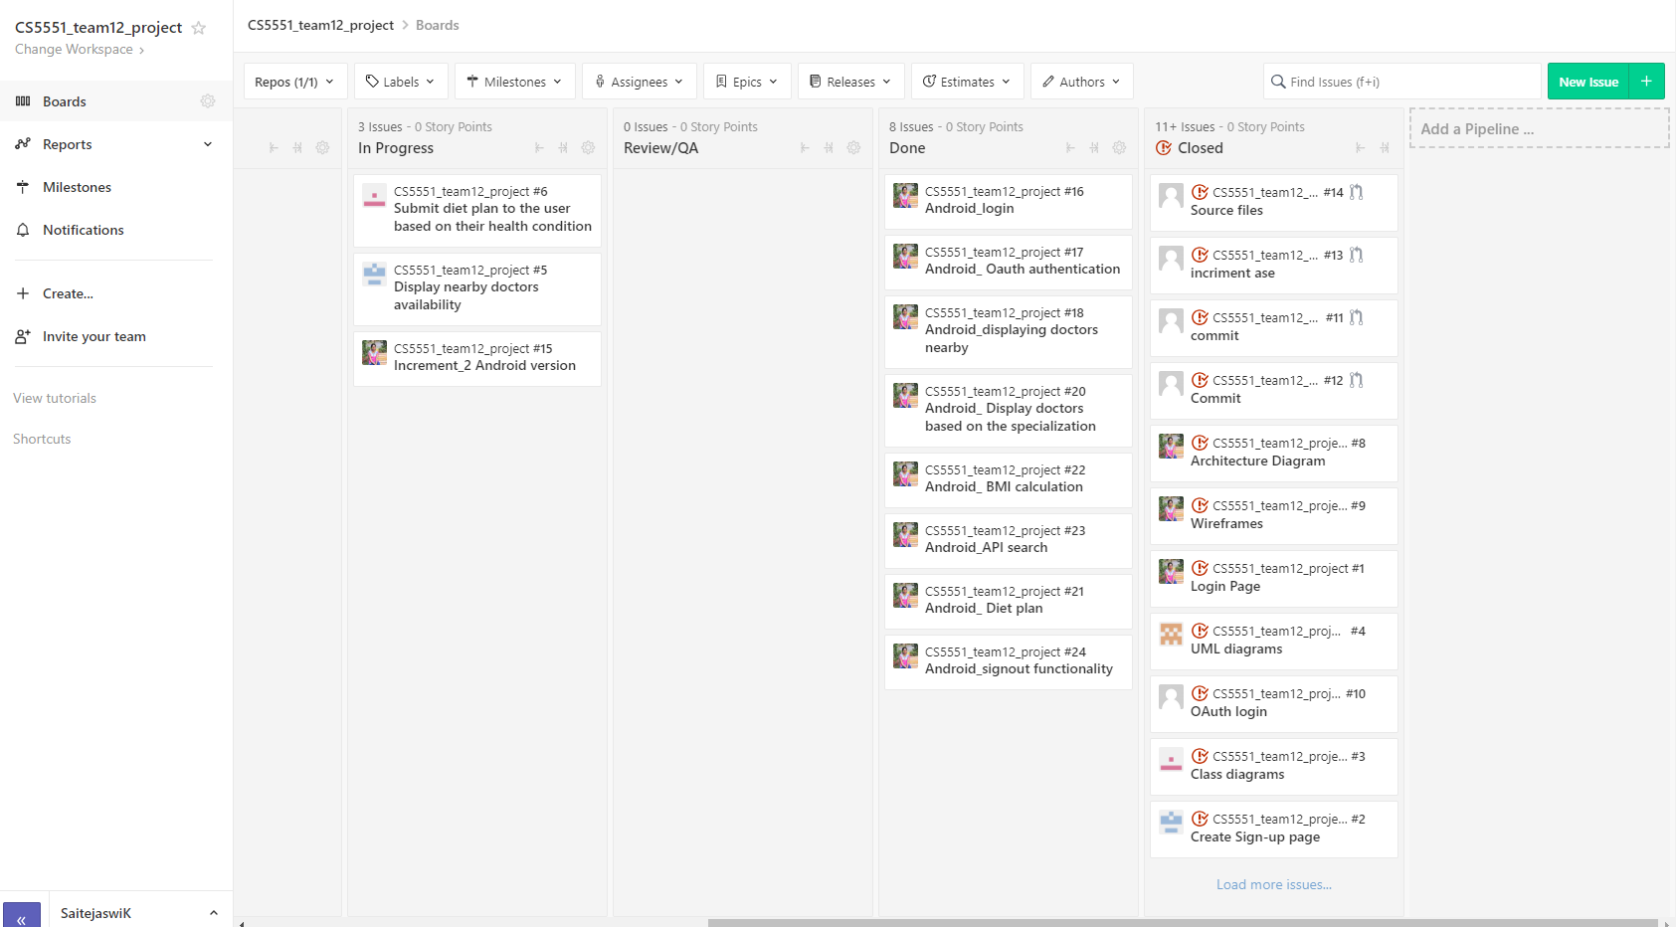

**First Increment Report:**

* In the phase 1 of the project, we have implemented the authentication phase.
* Under authentication phase, login page has been implemented using local storage as well as with social login.
* In the social login phase, using Oauth2.0 google sign in and facebook login are implemented.

**Wireframes:**

* If the user has already registered he can directly login to the application.

Wireframes for login and signup page are as follows:

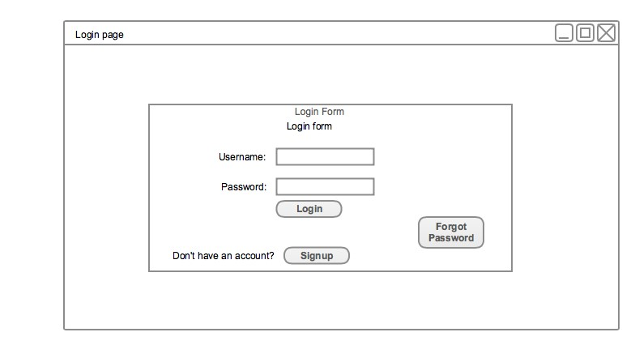

* If the user is not registered he can register to the application using Signup page

Wire frame for Signup page:

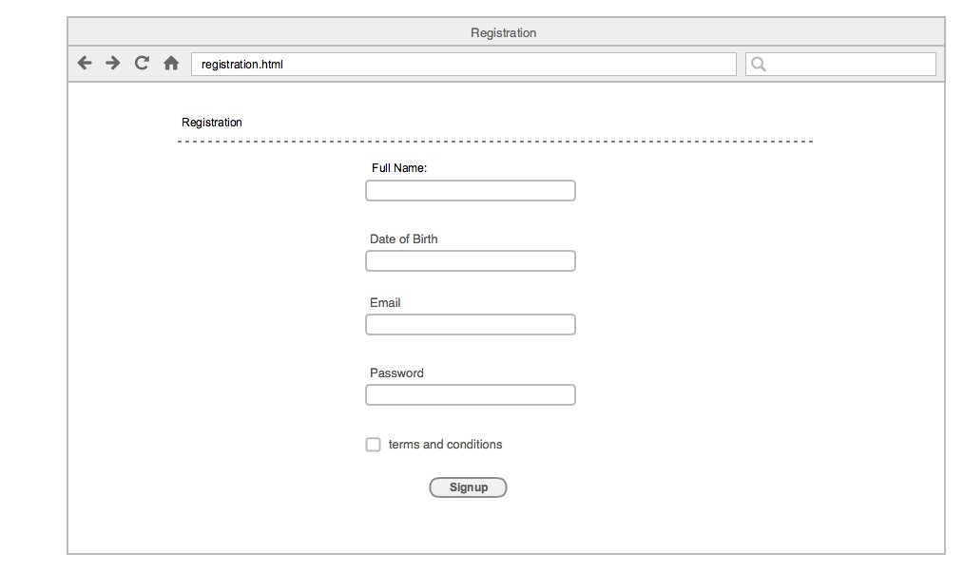

**UML DIAGRAMS:**

The major part of any project is to understand the workflow of the project where in the class diagram and sequence diagrams are very much helpful in going through the process workflow.

The class diagram of the project is as follows:

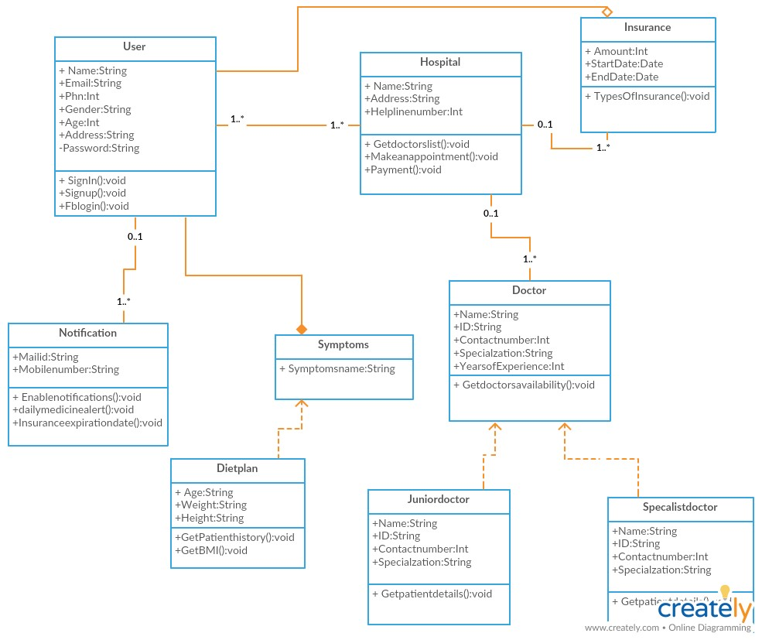

* Another important UML diagram which is very helpful in the user stories is a sequence diagram.

**Sequence Diagram:**

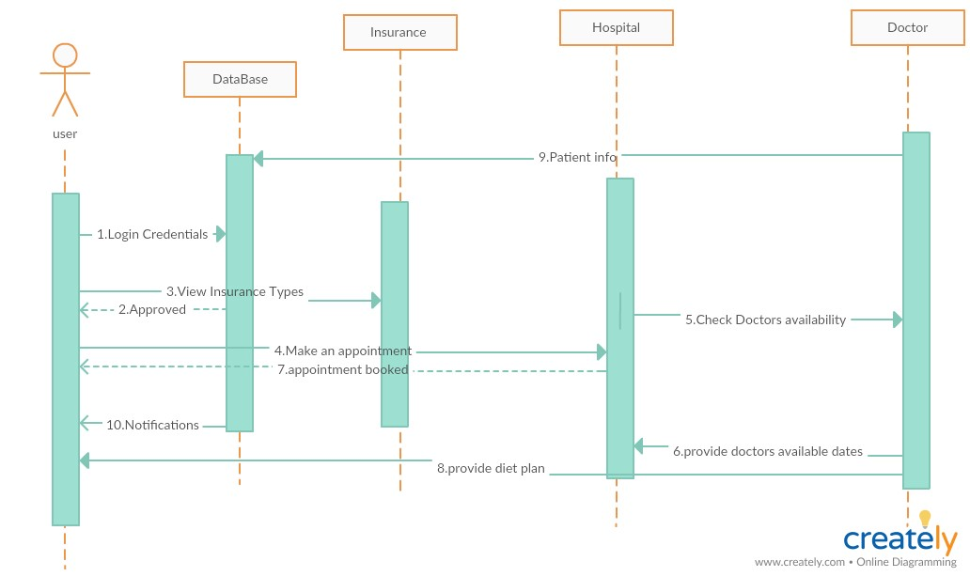

**Architecture:**

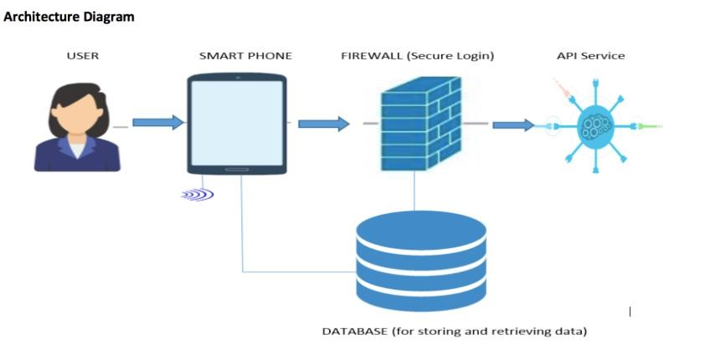

**Implementation:**

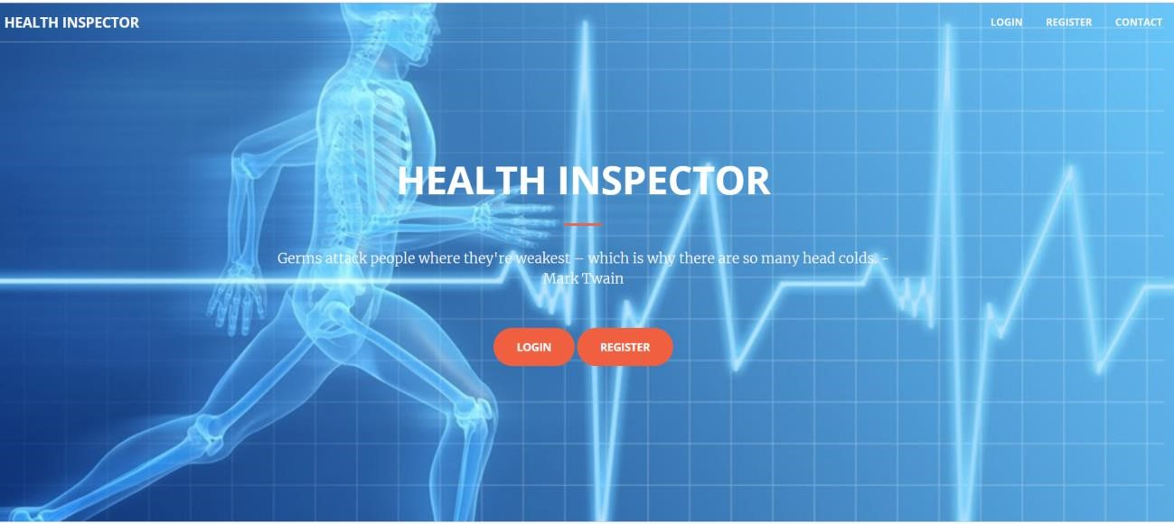

Login page

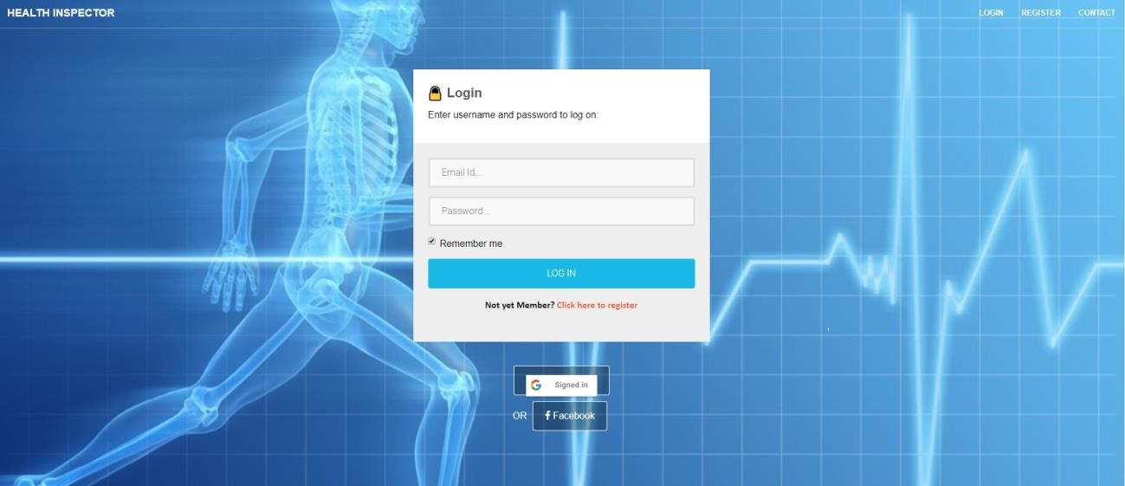

Oauth Login

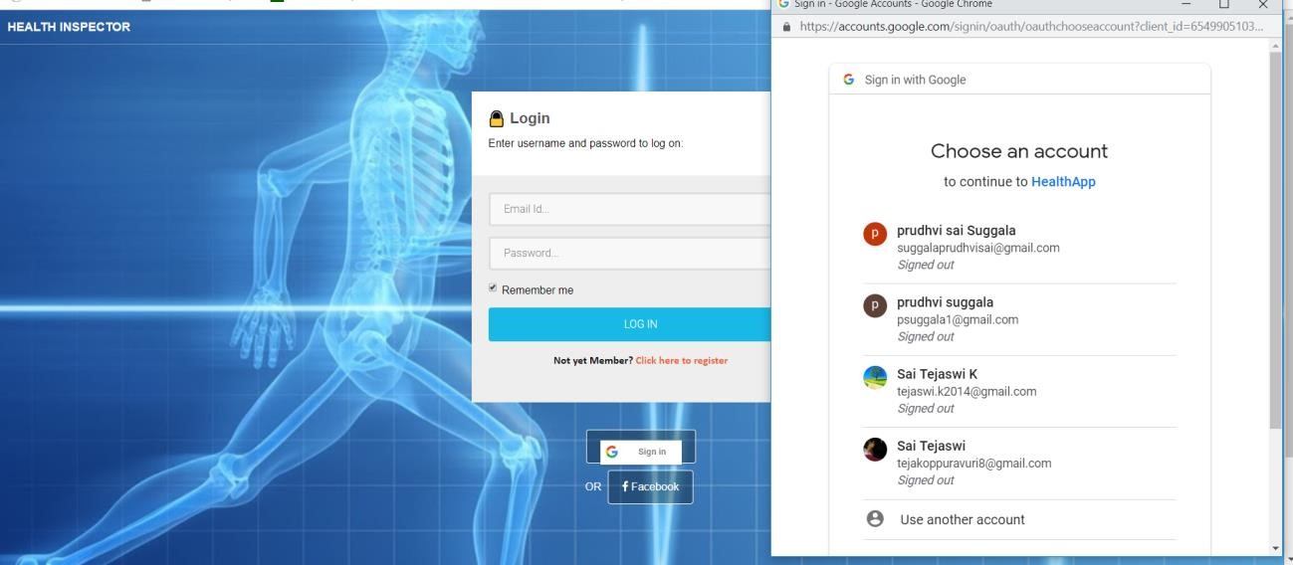

Facebook Oauth:

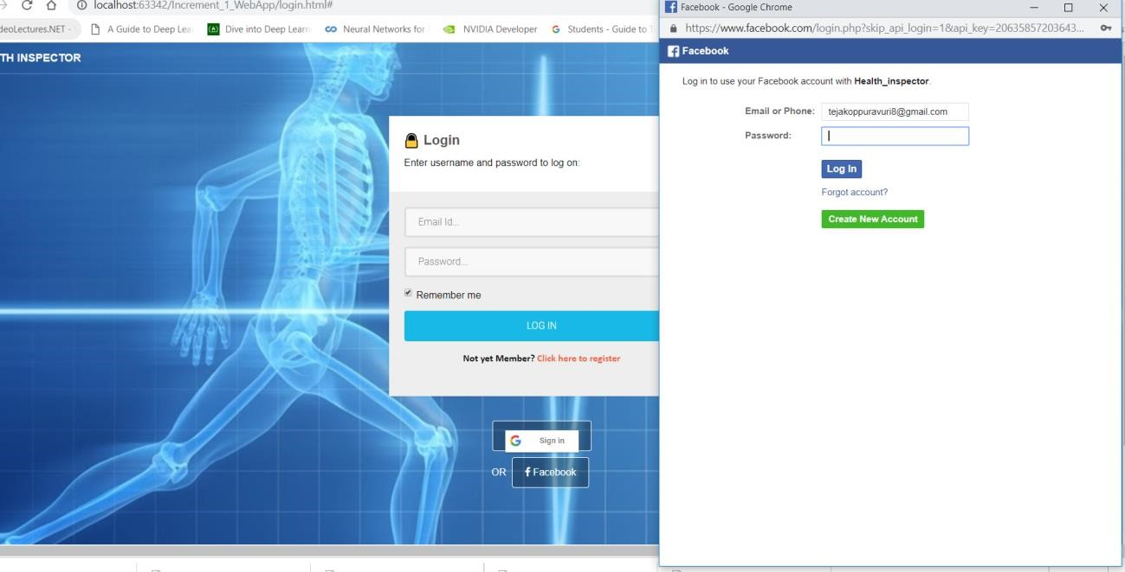

Signup page:

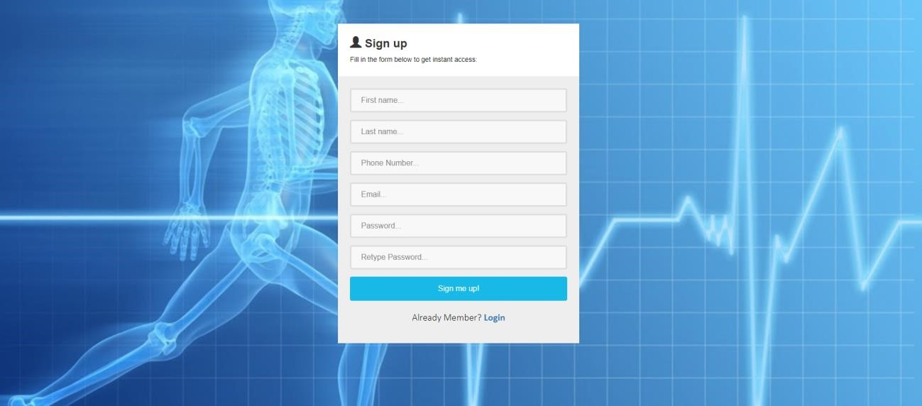

If the user has been successfully logged into the application, they are redirected to the home page.

Home page:

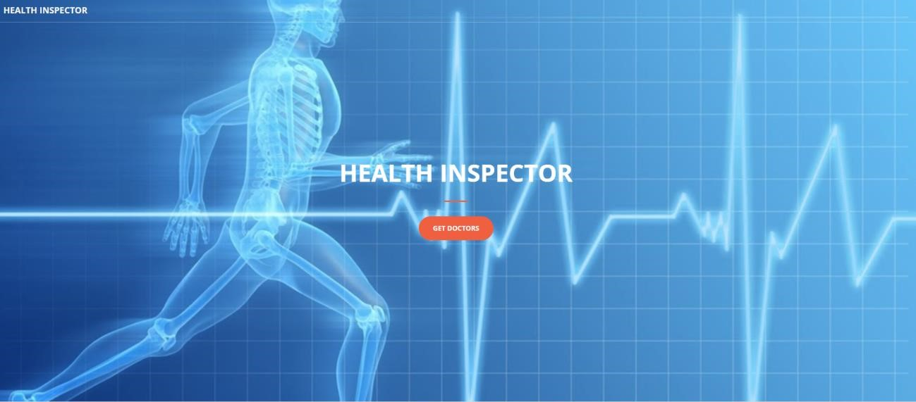

For the phase 1 we have used a *Better Doctor API*  in order to retrieve the list of doctors available. So in order to show the doctors available user has to click on the Get Doctor button which will retrieve the doctors list.

The result is as shown:

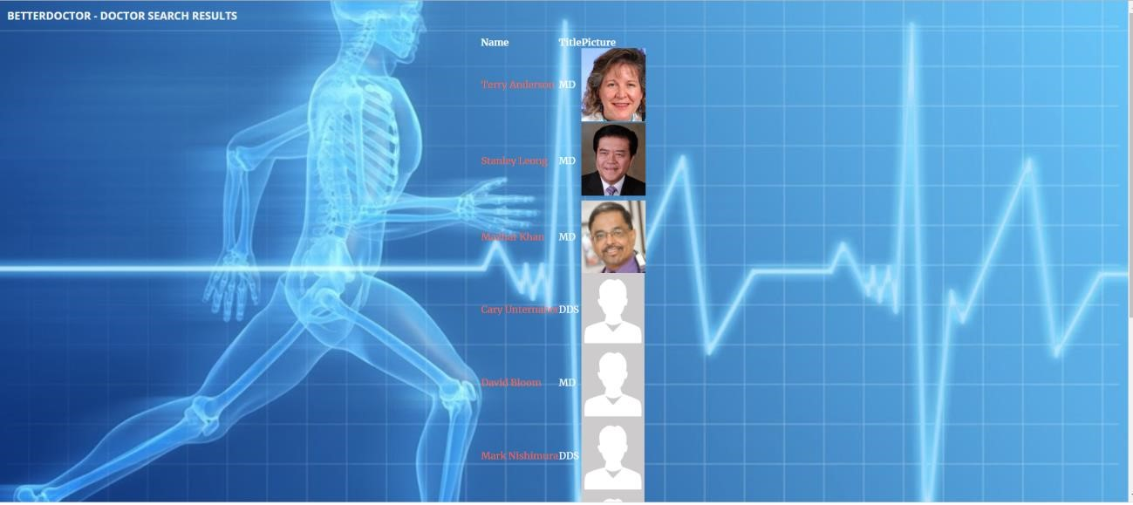

About page displays the glimpse of the project proposal.

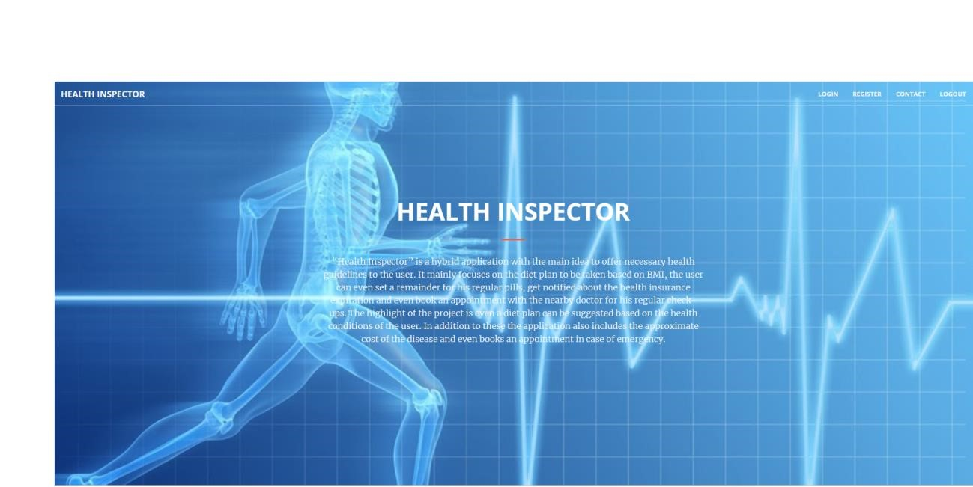

Contact Page displays the location and also the details of the project team.

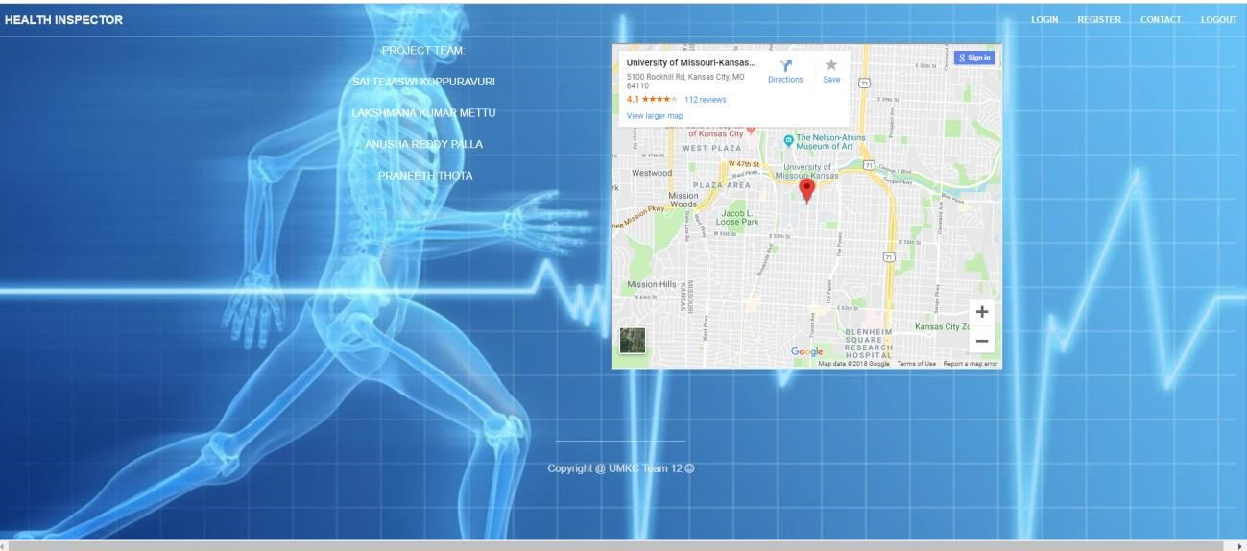

**Second Increment Report:**

In the second increment after the discussion, transformation from web to mobile has been happened. Our team was interested in designing the mobile app in two versions.

1. Using Android
2. Using Ionic.

**Increment Report for the Android Version:**

Login credentials for the user have been created.

**Authentication:**

* Firebase Login UI Auth for social Login (Mobile, Email, Google Login)
* Fetching SHA-1 for release.jks and Substitute that SHA-1 value in firebase console for Authentication
* Firebase SignOut

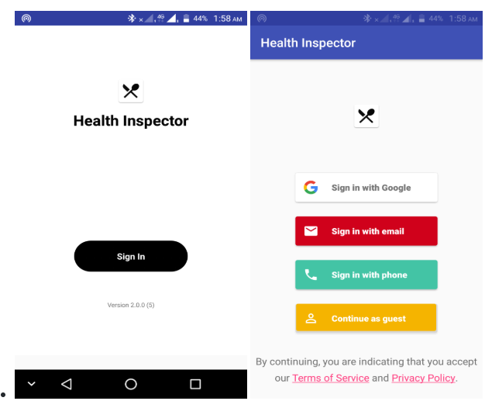

**Doctor Search with Better Doctors API:**

• Drop down (Spinner) to specify specialization in doctor search query  
• Making REST Call with lat,lng, limit=10 and specialization

@GET <https://api.betterdoctor.com/2016-03-01/doctors?location=37.773%2C-122.413%2C100&user_location=37.773%2C-122.413&skip=0&limit=10&user_key=76a2878a9e8d28dcd556ba0c53461174&specialty_uid=pediatrician>   
And parsing it in Home Activity with RecyclerView

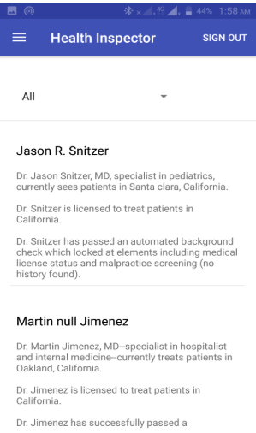

* The implementation based on the doctors specialization has been developed.

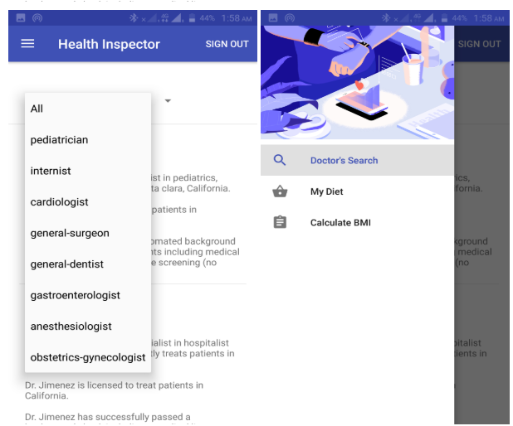

**Calculating Meals for given target calories using Spoonacular API:**

•Taking Calories per day input through EditText

•Making REST Call with target calories per day

@GET <https://spoonacular-recipe-food-nutrition-v1.p.mashape.com/recipes/mealplans/generate?timeFrame=day&targetCalories=2000> +  
Pass Keys in header

X-Mashape-Key: 1Dnz7LuzBVmshia88a9IKqmf7n82p1v8KSGjsnP7R2gBashGJA (key)  
X-Mashape-Host: spoonacular-recipe-food-nutrition-v1.p.mashape.com (key)  
  
And parsing it in MyDiet Activity with Recycler View and in Nutrients View

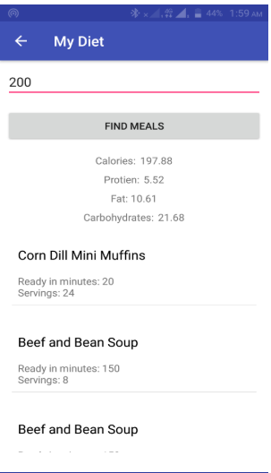 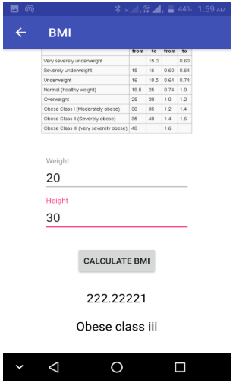

**Libraries Used / Dependencies:**

1. Firebase Auth UI for social login.
2. Retrofit, OkHTTP for making network calls
3. GSON to parse JSON response to java object
4. Google Maps API for location

**Tasks remaining:**

1. Writing test cases
2. Using geolocation for displaying the doctors nearby

**Third Increment Report:**

* In the third increment we have implemented displaying the nearby doctors.
* A feature of sending notification has been added as a key feature.
* A user can be able to book an appointment with the doctor and a particular appointment details can be shown in the “My Appointments” tab.
* The user gets notified 15 min prior to his/her appointment as a remainder.
* In case of timings mismatch, the user can also cancel the booked appointment.
* Notifications are sent using Google Calendar and using AWS server.

Changes in the Diet plan:

* Instead of showing the user a single diet plan multiple diet plans have been shown, which is similar to a week’s plan.

